Date:10.07.2021
FOR PARENTS OF CLOSE CONTACTS OF A CONFIRMED CASE OF COVID 19 at Mottram Primary School
Instruction to Self-Isolate until 17th July inclusive.
Dear Parent,
We have been advised by Public Health England that there has been a confirmed case of COVID-19 within the Year 2 of Purple Class.
As advised Public Health we have risk assessed and have identified that your child, has been in close contact with the affected person. In line with the national guidance, your child must now stay at home and self-isolate up to and including 17.07.2021 which is 10 days since they were last in contact with the confirmed case and can return to school on 19th July 2021.
In calculating the self-isolation end date, we have used the official national test and trace guidance under which the date of last contact with the positive case is considered to be day 0 of a 10-day self-isolation period and where day 11 is the day when self-isolation is lifted and your child can return to school, as set out below:

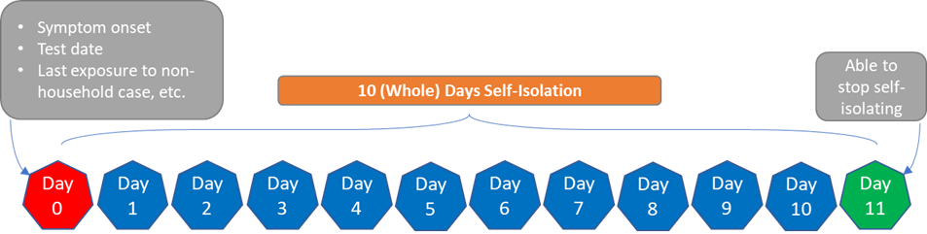
We are aware that this may differ from how you could interpret the online information that is available, but we are advised to use this method by Public Health England as it reflects a recent change to the national calculation methodology.
We are asking you to do this to reduce the further spread of COVID-19 to others in the community.
If your child is well at the end of the period of self-isolation, then they can return to usual activities. A negative test does not mean that your child can return to Mottram Primary School earlier than the period of self-isolation.
Other members of your household can continue normal activities provided your child does not develop symptoms within the self-isolation period.
Please see the link to the PHE Staying at Home Guidance for contacts who do not live with the confirmed case of Covid-19:
https://www.gov.uk/government/publications/guidance-for-contacts-of-people-with-possible-or-confirmed-coronavirus-covid-19-infection-who-do-not-live-with-the-person/guidance-for-contacts-of-people-with-possible-or-confirmed-coronavirus-covid-19-infection-who-do-not-live-with-the-person
Testing for contacts
People who have been in contact with someone who has tested positive with COVID-19 can now get a PCR test during their 10-day self-isolation period, whether or not they have symptoms. Around 1 in 5 people who have been in close contact with a person with COVID-19 will go on to have COVID-19 themselves, and around 1 in 3 of those will have no symptoms but can still spread the virus. Getting a test when you’re a contact helps to find if you’re one of those people and, if so, to ensure your contacts are self-isolating. This is how we break the chains of transmission. Even if you test negative, you will still need to complete your 10-day self-isolation period, because the virus can incubate for that time.

To reduce the risk of further transmission and identify any further COVID-19 positive residents, Public Health England are now requesting all identified contacts, including educational bubbles, organise a PCR test early in their isolation, unless they have had a positive PCR test in the last 90 days. Therefore, as your child has been identified as a contact, unless they have had a positive PCR test in the last 90 days please book a test at http://www.nhs.uk/coronavirus or call 119.

What to do if your child develops symptoms of COVID-19
If your child develops symptoms of COVID-19, you should arrange for testing for your child via https://www.gov.uk/guidance/coronavirus-covid-19-getting-tested or by calling 119.
Whilst waiting for the test result, all other members of the household should stay at home and self-isolate.
If the test result is positive, all other household members must stay at home and not leave the house for 10 days from the day when the first person in the house became ill. Household members should not go to work, school or public areas and exercise should be taken within the home.
If the test result is positive, your child will be required to self-isolate for a period of 10 days from the day that their symptoms started. Please inform us if your child has a positive test result.
If your child’s test result is negative, anyone in your household who is isolating solely because of your child’s symptoms can stop isolating.
Household members staying at home for 10 days will greatly reduce the overall amount of infection the household could pass on to others in the community.
If you are able to, move any vulnerable individuals (such as the elderly and those with underlying health conditions) out of your home, to stay with friends or family for the duration of the home isolation period.
Please visit the link to PHE guidance for households with possible Covid-19 infections:
https://www.gov.uk/government/publications/covid-19-stay-at-home-guidance/stay-at-home-guidance-for-households-with-possible-coronavirus-covid-19-infection
Symptoms of COVID-19
The most common symptoms of coronavirus (COVID-19) are recent onset of:
- new continuous cough and/or;
- high temperature and/or;
- a loss of, or change in, normal sense of taste or smell (anosmia).
For most people, coronavirus (COVID-19) will be a mild illness.
If your child does develop symptoms, you can seek advice from NHS 111 at https://www.nhs.uk/conditions/coronavirus-covid-19/check-if-you-have-coronavirus-symptoms/or by phoning 111.
How to stop COVID-19 spreading
There are things you can do to help reduce the risk of you and anyone you live with getting ill with COVID-19:
- wash your hands with soap and water often – do this for at least 20 seconds;
- use hand sanitiser gel if soap and water are not available;
- wash your hands as soon as you get home;
- cover your mouth and nose with a tissue or your sleeve (not your hands) when you cough or sneeze;
- allow ventitation in the house through opening windows;
- put used tissues in the bin immediately and wash your hands afterwards.
Test and Trace Support Payments
If a person is asked to self-isolate by NHS Test and Trace and is on a low income, unable to work from home and will lose income as a result, they may be entitled to a payment of £500 from their local authority under the Test and Trace Support Payment scheme. This now applies to parents/ carers who cannot work from home and will lose income by self-isolating or staying at home to care for the child.
Further details are available via: www.gov.uk/test-and-trace-support-payment
Further Information
Further information is available at https://www.nhs.uk/conditions/coronavirus-covid-19/.
You will be sent an email on Monday pm 12th July with work for your child to undertake whilst isolating.
Yours sincerely,
Mrs Scattergood

