

**R.E**

*How do Christians know how to live a good life?

*St George’s Day

*The Prayer of Saint Francis of Assisi

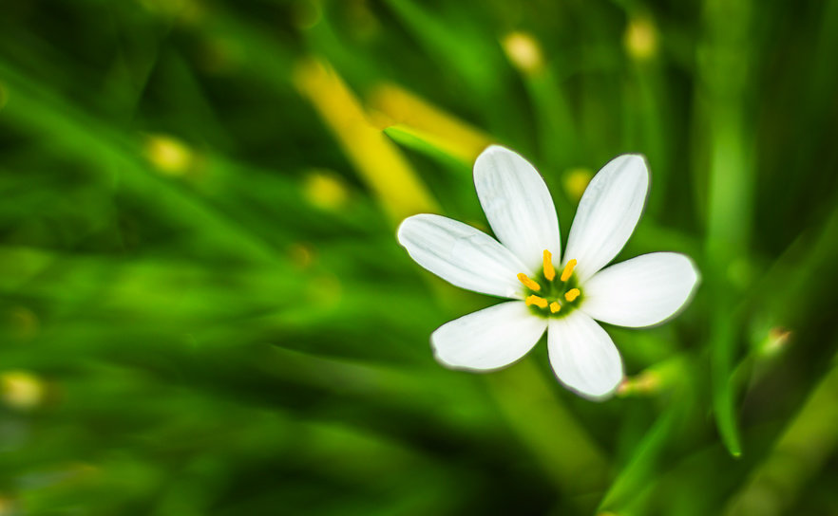

**Maths**

*Decimals including tenths, hundredths, thousandths

*Rounding decimals

*Ordering decimals

*Making links between fractions, decimals, percentages

*Properties of 3D shapes

*Arithmetic

**Science**

*Lifecycle of a flowering plant

*Importance of insects in pollination

*Practical experience of sowing seeds/growing plants

**Modern Foreign Language:** French

**Literacy/Drama**

*To write a ‘day in the life of’.

*To write a persuasive advertisement.

**ICT**

*To use word processing programmes.

*To use graphing software

**Children will need their P.E kit this half term on Monday and Friday.**

**Geography**

*Locational knowledge

*Human and physical Geography

*Geographical skills and fieldwork

**P.E:**

*Cricket

**Homework will be given out on Thursday and should be handed in on the following Tuesday. Spellings will be given out on Friday and tested the following Friday.**

**Mottram Primary School**

What will blue class be doing this half term?